Canvas Beagles
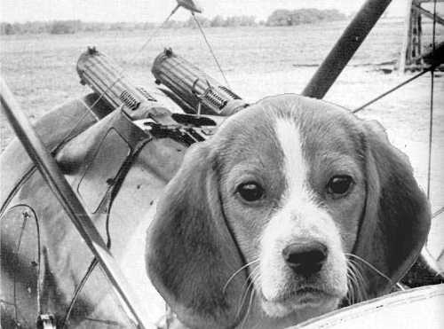

WWI aircraft campaigns for Canvas Eagles
by Ian Hayward, Jef Croucher, and friends at Wassail Games Club
canvasbeagles.pbwiki.com
Version 1.7
26/12/08
Canvas Beagles
Contents
1 Introduction 1
2 Squadron structure 1
3 Prestige points 1
4 Crew experience points 1
5 Determining missions 1
6 Aborting a mission 2
7 Fuel 2
8 Bombing 2
9 Archie 3
10 Notes on missions 3
11 Weather 4
12 Tables 5
13 Examples 6

Document history
Date | Author | Sections | Comments
26/12/08 | IanH |  | Retypeset in Times New Roman
12/05/07 | IanH | 11.2 | Added cloud rules

Introduction
Canvas Beagles is Wassail Games’ campaign rules for use with the Canvas Eagles WWI aircraft wargame rules.
These rules are heavily based on those of the Ottawa Canvas Eagles Group (see http://canvaseagles.diplomacy.ca/canvas_eagles.htm). Unless stated otherwise all Ottawa and standard Canvas Eagles rules are in force.
For more information see:
Canvas Beagles: canvasbeagles.pbwiki.com
Wassail Games club: wassailgamesclub.googlepages.com
IanH’s pages: www.iandrea.co.uk/wargames

Squadron structure
There are two squadrons, one Royal Flying Corps squadron, and one German "Jasta".
Each squadron will start with eight aircraft, corresponding to the models we currently have available. See Tables 1 and 2.
As the campaign progresses new aircraft will be introduced as new models are acquired.
Each squadron has 6 single-seater pilots, 2 two-seater pilots, and 2 observers.

Prestige points
These are awarded for completing missions and can be used to 'buy' new aircraft etc.
See Section 1 of the Ottawa Rules.

Crew experience points
See Canvas Eagles, page 22.

Determining missions
Each turn represents a day.
Each side secretly rolls a 1D10 against Table 3 to determine the mission to be undertaken (the ‘real’ mission) and then allocates zero to four aircraft (with corresponding crews) to the mission.
Each side secretly rolls a second 1D10 and determines another mission (the ‘dummy’ mission).
Both sides then reveal all four missions and secretly allocate zero to four aircraft and crews to each unallocated mission.
Prestige points are won during missions as detailed in Section 1 of the Ottawa Rules, with the following exceptions:
- Points for successfully completing a mission are only given for the ‘real’ mission.
Commanders can use the Canvas Beagles Mission Planner to help in planning.
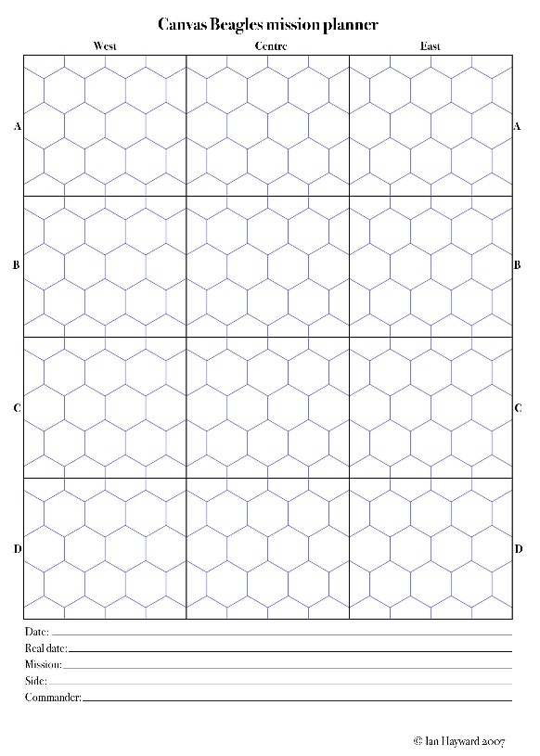

Aborting a mission – these rules are not being used at present!
Each aircraft on a mission has a chance of aborting because of mechanical failure etc. Roll 1D10; a roll of 10 means the aircraft aborts. See Table 4 for modifiers. Aircraft that abort can be repaired if mechanics are available.
If the aborting aircraft is a two-seater necessary for the mission, the commander has the option of aborting the whole mission.

Fuel
Aircraft undertaking missions may begin the tabletop game less fuel that in the standard Canvas Eagles rules (see Table 3 for details). This modification represents the fuel expended getting to the mission.
In addition, deduct one fuel point for each level above 4 of the plane’s starting altitude. For example: start at level 8, deduct 6 fuel points.
Aircraft that exit a tabletop game without fuel (this includes aircraft that use their last fuel point to exit the board) will not be able to return to their airfield. Determine the outcome using the rules given in Section 11 (p. 21) of Canvas Eagles.
If this occurs to aircraft undertaking one of their real or dummy missions, the landing will occur behind enemy lines. Crew must check for evasion. Aircraft are lost.
If this occurs to aircraft involved in one of the enemy’s missions, the landing will be in friendly territory. No evasion check is needed. Aircraft will be returned to the squadron the next day.

Bombing
Bombing capacity and accuracy modifiers are given on Ottawa, p. 3.

Archie
Airfield and HQ hexes have light archie.
Use the table on p. 19 of Canvas Eagles to determine the number of additional sites per side (normally there will only be one side holding the ground on the table, the only exception being the trench strafing mission).
Archie can be deployed anywhere on the table behind friendly lines
Idea: should we have some dummy archie counters?

Notes on missions

Table layout
The table consists of 12 blocks of hexes, arranged in 4 rows (A to D) and three columns (West, Centre, East). In the following descriptions ‘F(riendly)’ refers to the column closest to your airfield (i.e. ‘West’ for British , ‘East’ for German) and ‘E(nemy)’ refers to the column furthest from your airfield (i.e. ‘East’ for British, ‘West’ for German).
Hex blocks are thus referred to as FA for Friendly column, row A, etc.
All deployments in the mission table are described from the point of view of the defender.

Procedures common to all missions
Each side in secret should follow the following procedures.
Defending side rolls for number of archie sites (p. 19 of Canvas Eagles), and then deploys them as detailed in the mission notes (exception: Fighter Sweep has no archie present).
Defending aircraft should have patrol loops defined within the appropriate blocks detailed in the mission notes. The loops should indicate the direction of ‘orbiting’ and be broken into a decent number (6, 10, 12, 20) of equal segments. At the start of the game roll dice are rolled to determine the initial placement of aircraft. The loops can extend through several hex blocks, if desired. Altitudes should be assigned for each aircraft. Several aircraft can be assigned to the same loop – designate at leader and indicate the relative positions of the wingmen.
Attacking aircraft should indicate their entrance hex (along their friendly table edge), and their starting altitudes and directions.

Exiting the table
Attackers can only leave the table on edges behind their own trench lines, or from the friendly edge if they are behind enemy lines.
Defenders can only leave the table on north and south edges behind their own trench lines, or on their friendly edge.

Weather

Starting weather
There are three main weather types: calm, cold front, warm front.
At the start of the game determine the weather type for the first day: roll 1D6: 1-4: calm; 5: cold front; 6 warm front.

Calm
Roll each day: on a roll of 6 a front will appear the next day. Roll 1D6: 1-3: cold front; 4-6: warm front
Clouds are present on a roll of 1-2 on 1D6.
If clouds are present, roll 2x1D6 and add 2 to both of them. The smaller number is the height of the base, the upper number the height of the top (inclusive).
For each mission roll 1D6: 1-2 indicates one cloud is present, 3-4 two clouds, 5-6 three. Randomly allocate each cloud to different one of the 12 rectangles of the table.
A plane is deemed to have entered the cloud if it is within the height range of the cloud and is in the rectangle (half hexes: pilot can determine if he is in or out).
Once in a cloud the aircraft is removed from the board. It returns in 4 turns, having expended 4 fuel points, with a starting speed of 1 (which it can accelerate to speed 2 if desired, that turn). It is randomly allocated to a hex outside the cloud rectangle (or one of the half-in-half-out hexes), in a random direction that will take it out of the cloud. It has the same altitude as when it entered the cloud.

Cold front
On first day clouds extend from levels 1 to 10. Torrential rain. No flying or land movement.
On subsequent days storm base raises by 1D6. When cloud base is 5 or over rain stops and flying and land movement can occur.
When cloud base is over 10 the cold front is over. The weather will become calm.

Warm front
On first day clouds extend from level 10 down to level 10-1D6. Each day the cloud base drops by 1D6. When the base reaches 1 or below torrential rain occurs. Roll 1D6. On a roll of 2-6 the next day will be calm weather; otherwise the rain continues.

Effect of clouds
Any aircraft entering a cloud level is assumed to have left the table immediately.

Tables

Table 1: British aircraft
Aircraft | Number | Seats
SE5a | 3 | 1
Sopwith Camel | 3 | 1
RE8 | 1 | 2
Bristol Fighter | 1 | 2

Table 2: German aircraft
Aircraft | Number | Seats
Albatros DVa | 4 | 1
Fokker DVII | 2 | 1
Halberstadt CLII | 1 | 2
Hannover CLIII | 1 | 2

Table 3: Mission table
1D10 | Mission | Location | Friendly fuel mod | Enemy fuel mod
1 | Observe enemy airfield | Hinterland | -10% | None
2 | Observe enemy HQ | Hinterland | -10% | None
3 | Observe enemy troop concentration | Hinterland | -10% | None
4 | Bomb enemy airfield | Hinterland | -10% | None
5 | Bomb enemy HQ | Hinterland | -10% | None
6 | Directing artillery fire | Support lines | -5% | -5%
7 | Strafe enemy trench line | Front lines | -5% | -5%
8 | Balloon busting | Support lines | -5% | -5%
9 | Fighter sweep | German support lines | -10% if Allied  -5% if German | -5% if Allied  None if German
10 | Choose one of the above |  | n/a | n/a

Table 4: Aborting a mission modifiers
Attribute | Modifier
Ace | -1
Novice | +1
Serious wound | +1
Aircraft has critical damage | +1

Table 5: The missions
ID | Mission | Table layout | Notes
1/4 | Observe/bomb enemy airfield | A | Any defending aircraft not allocated to a mission can take off when the attackers enter the table.
2/5 | Observe/bomb enemy HQ | A
3 | Observe enemy troop concentration | B | Observing area is in CB, CC, on enemy trench hexes
6 | Directing artillery fire | B | Observing area is one hex behind friendly trench hexes
7 | Strafe enemy trench line | B
8 | Balloon busting | C | Balloon starts raised unless clouds prevent observation.
9 | Fighter sweep | Clear | No archie present

Table layout A | Table layout B | Table layout C

Examples

Example of mission determination
British squadron has a full complement of 8 aircraft. The commander rolls and gets a real mission of 'Balloon busting' and a dummy mission of 'Bomb enemy HQ'.
He allocates 3 aircraft to Balloon busting and none to Bomb enemy HQ.
The German squadron also has a full complement. The commander rolls and gets ‘Directing artillery fire’ (real) and ‘Bomb enemy airfield’ (dummy). He allocates 4 aircraft to ‘Directing artillery fire’ and 1 to ‘Bomb enemy airfield’.
Both commanders reveal all four missions.
The British commander then allocates 3 aircraft to the German’s ‘Directing artillery fire’ mission and 2 to the ‘Bomb enemy airfield’ mission.
The German commander assigns his remaining 3 aircraft to the British ‘Bomb enemy HQ’ mission.
The following games with then be played, in any order:
British real mission ‘Balloon busting’, 3 British versus 0 German.

Mission | Type | British aircraft | German aircraft | Comments
British real | Balloon busting | 3 | 0 | Game needs to be played because British aircraft can be brought down by German archie.
British dummy | Bomb enemy HQ | 0 | 3 | No game need be played.
German real | Directing artillery fire | 3 | 4 | Should be a good scrap.
German dummy | Bomb enemy airfield | 2 | 1 | The German commander was probably hoping for an unopposed bombing run. Might be a good idea to abort the mission!

Typical weather sequence.
Day | 1 | 2 | 3 | 4 | 5 | 6 | 7 | 8 | 9 | 10 | 11 | 12 | 13 | 14
Type | C | C | C | W | W | W | W | [W] | [W] | C | C | C | [K] | K
Cloud top | - | - | - | 10 | 10 | 10 | 10 | 10 | 10 | - | - | - | 10 | 10
Cloud base | - | - | - | 7 | 6 | 3 | 2 | 0 | 0 | - | - | - | 1 | 5
Comments |  |  |  |  |  |  |  | TR | TR |  |  |  | TR
C = calm; W = warm front; K = cold front; TR = torrential rain.
[] indicates flying not possible

Example mission planner
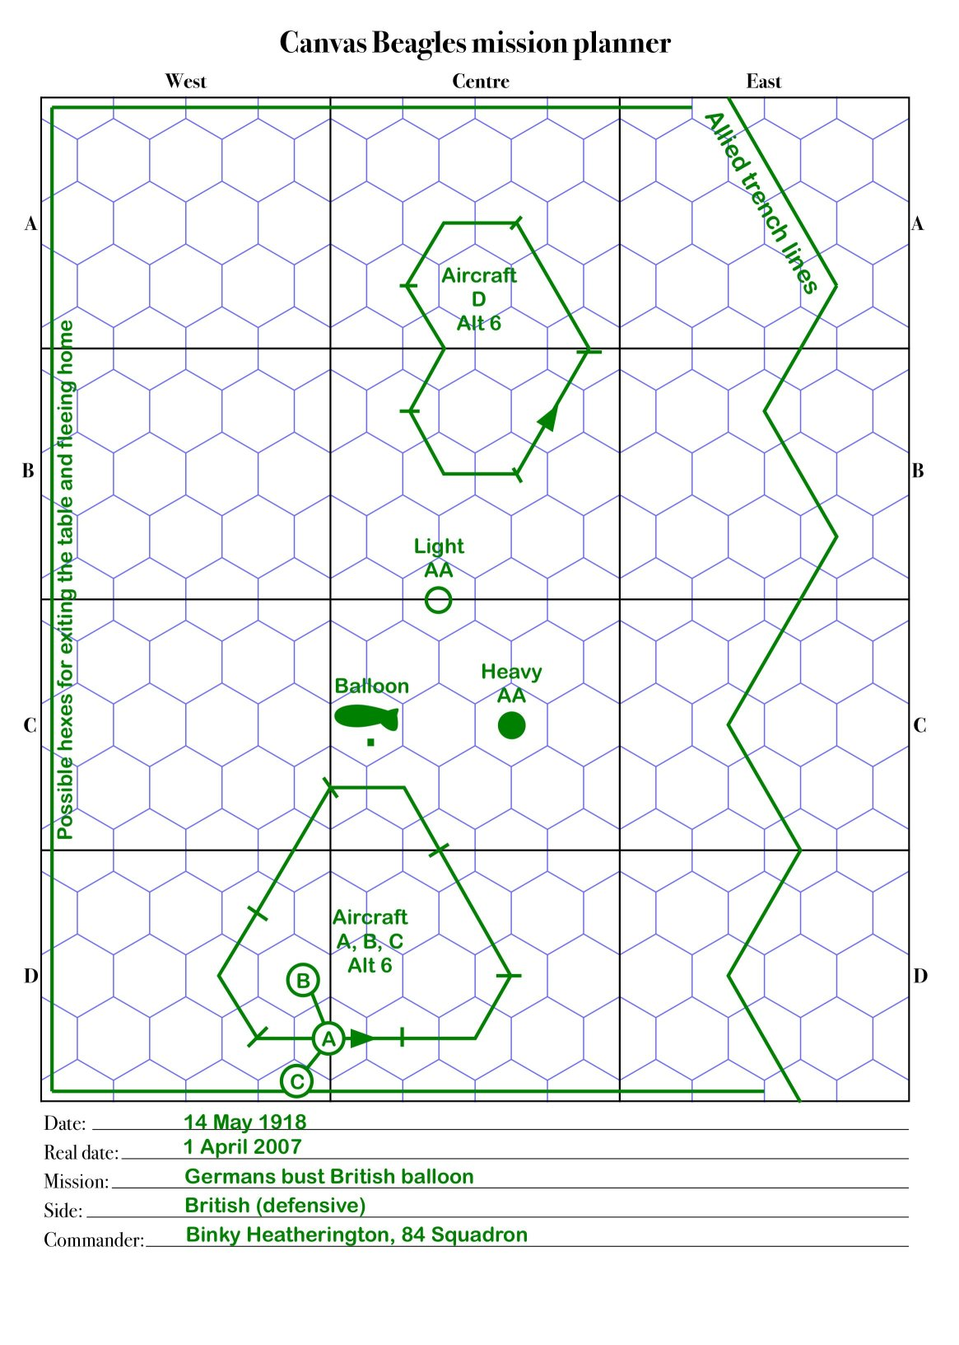

The larger reductions in fuel for the Allies reflect their aggressive patrolling over enemy lines. German fighter sweeps are taken to be over their own lines.

